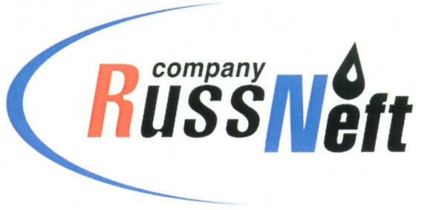
PJSC “RUSSNEFT”
PRESS SERVICE

Tel.: (495) 411-63-24; (495) 411-63-21  Fax: (495) 411-63-19  E-mail: pr@russneft.ru  www.russneft.ru | 115054, Moscow,  Pyatnitskaya str., 69

PRESS - RELEASE
February 6, 2023
Children of sponsored FC Neftyanik successfully performed at interregional competitions

The Neftyanik Football Club created under the patronage of PJSC «RussNeft», has successfully performed at the Interregional futsal tournament in Kuznetsk (Penza region).
The team of boys born in 2009 took 1st place among 10 participating teams, showing spectacular football and good player interaction.
The children born in 2011 took part in a regional tournament in Ulyanovsk, where they were the first among 12 regional teams of their age group, and went through to semifinal, but lost to rivals, eventually taking 3rd place.
Athletes of younger age groups showed good results at the Winter Futsal Championship in Syzran (Samara region).
The Neftyanik FC was founded in 2003 in the Novospasskoye working settlement of the Novospassky district of Ulyanovsk region, with the support of RussNeft. More than 200 children aged 7 - 17 are trained in the club.

About the Company:
PJSC “RussNeft” ranks among the top 10 largest oil companies by crude oil production in Russia.
The Company possesses a well-balanced portfolio of assets located in the key Russian oil and gas provinces (West Siberia, Volga-Urals and Central Siberia) as well as in Azerbaijan.
The headcount of the Company is around 8,000 employees.

Press Service of PJSC "RussNeft"
Phone: (495) 411-63-24
Fax: (495) 411-63-19
E-mail: pr@russneft.ru

