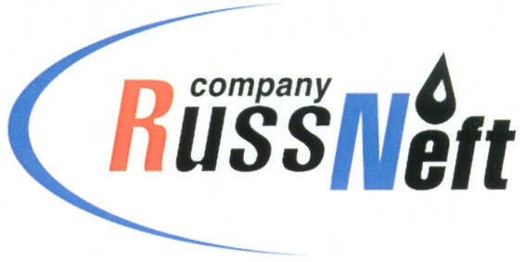
PJSC “RUSSNEFT” PRESS SERVICE

Tel.: (495) 411-63-24; (495) 411-63-21  Fax: (495) 411-63-19  E-mail: pr@russneft.ru  www.russneft.ru | 115054, Moscow,  Pyatnitskaya str., 69

OFFICIAL STATEMENT

July 17, 2018

PJSC "RussNeft" supports the initiative of the Federation of Automobile owners of Russia (FAR) to combat fuel underfills at the Russian gas stations. Of course, this public initiative is useful and necessary for both buyers and sellers in the retail fuel market.

FAR says in its statement: "Monitoring of AI-92 and AI-95 gasoline underfills was carried out at 34 gas stations in 13 constituent territories of the Russian Federation: the monitoring covered checks of: 5 vertically integrated oil companies (VIOC’s), 21 federal and regional refuel networks, and 8 gas stations owned by small networks or individuals".

The issue has received a wide response in the media but the format of the information from FAR, in our opinion, was not correct, as in the public comment the Federation did not specify the VIOC’s whose gas stations were subject to the measurements.

As a result, the number of unscrupulous companies included those who have no retail networks. Thus, PJSC “RussNeft” was included in the above-mentioned list whilst having no retail business within its perimeter.

The company asks to take into account the specifics of the organizational structure of RussNeft and not to mention it among the players of the retail market of the Russian Federation.

About the Company:

PJSC “RussNeft” ranks among the Top-10 largest oil companies by crude oil production in Russia.

The Company possesses a well-balanced portfolio of assets located in the key Russian oil and gas provinces (West Siberia, Volga-Urals and Central Siberia) as well as in Azerbaijan.

The Company’s 2P reserves are over 200 million tonnes (SPE).

The personnel of the Company, being a part of SAFMAR Industrial and Financial Group of Mikhail Gutseriev, is around 10,000 people.

PJSC “RussNeft” Press Service
Tel.: (495) 411-63-24, Fax: (495) 411-63-19
E-mail: pr@russneft.ru

