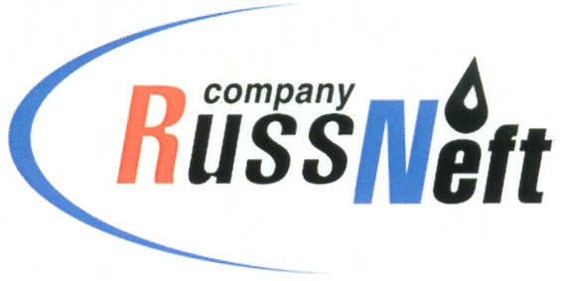
PJSC “RUSSNEFT”
PRESS SERVICE

Tel.: (495) 411-63-24; (495) 411-63-21  Fax: (495) 411-63-19  E-mail: pr@russneft.ru  www.russneft.ru | 115054, Moscow,  Pyatnitskaya str., 69

PRESS - RELEASE
December 15, 2023
RussNeft supports New Year’s performance in Saratov

PJSC “RussNeft” supported a New Year's theatrical production for young audience in Saratov.
The Saratov Kiselev Academic Youth Theater has chosen a new version of the fairy tale "The Scarlet Flower" for the New Year's performance this year.
The Saratov branch of RussNeft could not stand aside and backed the stage production loved by many generations. Traditionally, the theater invites children from large and low-income families to New Year's performances. The children will be able not only to watch the performance, which involves the leading artists of the Youth Theater, but also to participate in an interactive show with New Year's characters, to get charged with a festive mood and reach out with their peers from various districts of the region.
The Saratov branch is actively engaged in social and cultural projects in the region. In the outgoing year, RussNeft has supported significant cultural projects in Saratov: the XX International Documentary Melodrama Film Festival "Saratov Sufferings", the XI All-Russian Competition of Folk Song Performers named after L.Ruslanova, cultural and educational project-festival "Lessons of Tabakov".

About the Company:
PJSC “RussNeft” ranks among the top-10 largest oil companies by crude oil production in Russia.
The Company possesses a well-balanced portfolio of assets located in the key Russian oil and gas provinces (West Siberia, Volga-Urals and Central Siberia) as well as in Azerbaijan.
The headcount of the Company is around 8,000 employees.

Press Service of PJSC "RussNeft"
Phone: (495) 411-63-24
Fax: (495) 411-63-19
E-mail: pr@russneft.ru

