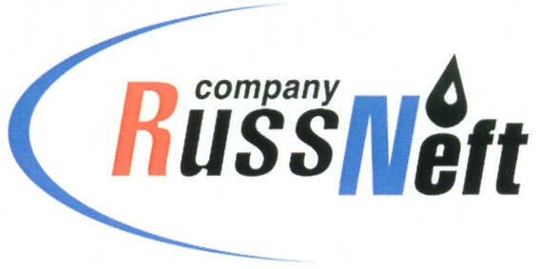
PJSC “RUSSNEFT”
PRESS SERVICE

Tel.: (495) 411-63-24; (495) 411-63-21  Fax: (495) 411-63-19  E-mail: pr@russneft.ru  www.russneft.ru | 115054, Moscow,  Pyatnitskaya str., 69

PRESS - RELEASE
November 16, 2023
PJSC "RUSSNEFT" PERFORMS A CAMPAIGN OF HIRING YOUNG SPECIALISTS WITH HIGHER PROFESSIONAL EDUCATION

PJSC "RussNeft" considers meetings with students of educational institutions in the regions of its presence to be an important element of activities aimed at attracting young promising employees to the Company.
In October and November, representatives of the Company’s Ulyanovsk branch held meetings with students of educational institutions from Ulyanovsk and Penza regions: Ulyanovsk Electrical and Mechanical College, College of Ulyanovsk State Technical University, Ulyanovsk Multidisciplinary College, Dimitrovgrad Technical College, Ryazanovsky Agricultural College, Inza State College of Industrial Technologies of Economics and Law, Kuznetsk Multidisciplinary College, Bolshenagatkinsky Technical School of Technology and Service, Novospassky Technological College.
During the meetings, employees of the company answered questions from students and talked about employment opportunities and working conditions at the enterprise, requirements for future specialists, measures to support young workers, and prospects for professional growth.
PJSC “RussNeft” Ulyanovsk branch permanently provides its production sites for internships to students of the region’s educational institutions.

About the Company:

PJSC “RussNeft” ranks among the Top-10 largest oil companies by crude oil production in Russia.
The Company possesses a well-balanced portfolio of assets located in the key Russian oil and gas provinces (West Siberia, Volga-Urals and Central Siberia) as well as in Azerbaijan.
The headcount of the Company is around 8,000 employees.

Press Service of PJSC "RussNeft"
Phone: (495) 411-63-24
Fax: (495) 411-63-19
E-mail: pr@russneft.ru

