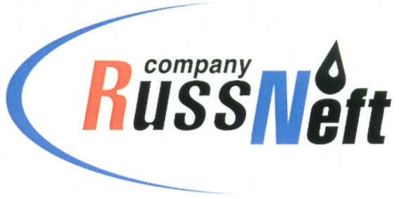
PJSC “RUSSNEFT”
PRESS SERVICE

Tel.: (495) 411-63-24; (495) 411-63-21  Fax: (495) 411-63-19  E-mail: pr@russneft.ru  www.russneft.ru | 115054, Moscow,  Pyatnitskaya str., 69

PRESS - RELEASE
February 15, 2024
Nizhnevartovsk branch of RussNeft supports charitable efforts in KhMAO

Nizhnevartovsk branch of PJSC RussNeft in 2023 allocated RUB4.8 mln. for charitable and sponsorship projects.
The branch provided backing to the projects aimed at promoting the distinctive culture and traditional economic activities of indigenous minorities of Khanty-Mansi Autonomous District – Ugra. RussNeft acted as a partner and founder of the special prizes of the professional contest among reindeer herders for the Cup of the Governor of Ugra.
With funding from the Company, celebrations dedicated to the Nizhnevartovsk district anniversary were held. In the context of the socio-economic agreement with the administration of the city of Raduzhny, RussNeft supported the implementation of municipal programs intended to expand the material and technical basis of educational, culture and art, sports, youth policy institutions, to conduct mass events of the city importance, and to develop public space in an urban environment.
In addition, RussNeft provided financial aid to the public organization of pensioners and veterans of the city of Raduzhny, the Novoagansk Children's School of Arts, the Orthodox communities of Raduzhny and Novoagansk, the Kyokushin Karate Federation, the All-Russian Society of the Blind, urban and rural preschool and general education institutions, cultural and sports institutions.

About the Company:
PJSC “RussNeft” ranks among the top-10 largest oil companies by crude oil production in Russia.
The Company possesses a well-balanced portfolio of assets located in the key Russian oil and gas provinces (West Siberia, Volga-Urals and Central Siberia) as well as in Azerbaijan.
The headcount of the Company is around 8,000 employees.

Press Service of PJSC "RussNeft"
Phone: (495) 411-63-24
Fax: (495) 411-63-19
E-mail: pr@russneft.ru

