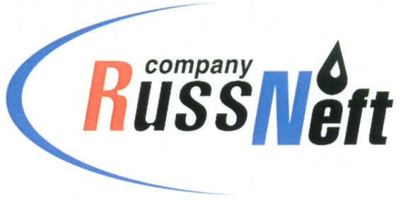
PJSC “RUSSNEFT” PRESS SERVICE

Tel.: (495) 411-63-24; (495) 411-63-21  Fax: (495) 411-63-19  E-mail: pr@russneft.ru  www.russneft.ru | 115054, Moscow,  Pyatnitskaya str., 69

PRESS - RELEASE
April 10, 2023

RussNeft has started to implement the anti-flood action plan

PJSC "RussNeft" has started to implement a plan of preventive measures related to snow melt and seasonal rise in water levels in reservoirs.

Thus, the Nizhnevartovsk branch of the Company set up emergency rescue units at the oil fields with the necessary stock of equipment and materials for prompt response to possible emergency situations and emergency recovery work. A procedure has been developed for notifying officials and emergency services.

Control over the anti-flood action plan implementation is entrusted to the central dispatching department of RussNeft. The main objective of the measures taken is to exclude possible incidents in the regions of the Company's operation.

About the Company:
PJSC “RussNeft” ranks among the top-10 largest oil companies by crude oil production in Russia.
The Company possesses a well-balanced portfolio of assets located in the key Russian oil and gas provinces (West Siberia, Volga-Urals and Central Siberia) as well as in Azerbaijan.
The headcount of the Company is around 8,000 employees.

Press Service of PJSC "RussNeft"
Phone: (495) 411-63-24,
Fax: (495) 411-63-19
E-mail: pr@russneft.ru

