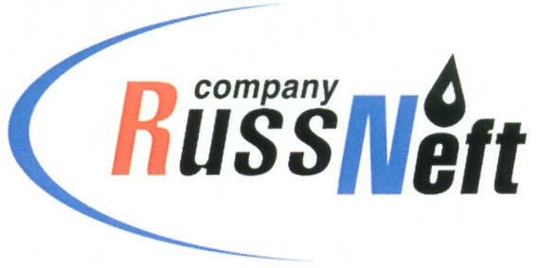

PJSC “RUSSNEFT” PRESS SERVICE

Tel.: (495) 411-63-24; (495) 411-63-21  Fax: (495) 411-63-19  E-mail: pr@russneft.ru  www.russneft.ru | 115054, Moscow,  Pyatnitskaya str., 69

PRESS RELEASE
July 29, 2022

PJSC “RussNeft” Replenishes the Forests of Western Siberia

In 2022 PJSC "RussNeft" increased the volume of reforestation works by another 44 ha. Thus, in three years, the planting of new trees covered an area of ​​442 ha with more than 1,700,000 seedlings planted.
This year, the Company has planted more than 162,000 seedlings. When reforesting, PJSC “RussNeft” uses improved and varietal seeds of forest plants adapted to the regional characteristics of the planting area. For the restoration of forests in Western Siberia, as a rule, pine seedlings are used, previously grown in nurseries to a height of 12-20 cm.
The reforestation program is being implemented on the territories allocated by the forestries to compensate for cutting down at infrastructure construction sites for oil production and seismic exploration.
PJSC “RussNeft” pays close attention to compliance with environmental legislation and prevention of negative impact of production activities on the environment.

About the Company:
PJSC “RussNeft” ranks among the top-10 largest oil companies by crude oil production in Russia.
The Company possesses a well-balanced portfolio of assets located in the key Russian oil and gas provinces (West Siberia, Volga-Urals and Central Siberia) as well as in Azerbaijan.
The headcount of the Company is around 8,000 employees.

PJSC “RussNeft” Press Service
Tel.: (495) 411-63-24, Fax: (495) 411-63-19
E-mail: pr@russneft.ru

