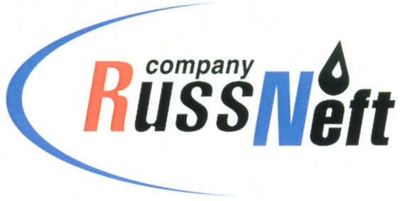
PJSC “RUSSNEFT” PRESS SERVICE

Tel.: (495) 411-63-24; (495) 411-63-21  Fax: (495) 411-63-19  E-mail: pr@russneft.ru  www.russneft.ru | 115054, Moscow,  Pyatnitskaya str., 69

PRESS - RELEASE
November 11, 2022
RussNeft continues its education project with Gubkin University

PJSC “RussNeft” continues a joint education project with the Gubkin Russian State University of Oil and Gas to prepare schoolchildren for the Unified State Exam for the purpose of their following admission to higher education institutions.
Applicants receive an educational intensive at regional preparatory courses (RPC) held by the Gubkin University`s teachers. Online classes are organized on the basis of the Company's branches.
Saratov and Nizhnevartovsk branches are traditional venues for the RPC. The list of students of regional preparatory courses includes not only the Company employee`s children, but also the seniors that showed excellent skills in major subjects and were granted reference letters from municipal administrations of the Saratov region.
All expenses for the organization and conduct of the RPC are borne by RussNeft.

About the Company:
PJSC “RussNeft” ranks among the top-10 largest oil companies by crude oil production in Russia.
The Company possesses a well-balanced portfolio of assets located in the key Russian oil and gas provinces (West Siberia, Volga-Urals and Central Siberia) as well as in Azerbaijan.
The headcount of the Company is around 8,000 employees.

Press Service of PJSC "RussNeft"
Phone: (495) 411-63-24
Fax: (495) 411-63-19
E-mail: pr@russneft.ru

