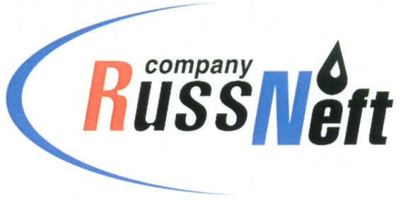

PJSC “RUSSNEFT” PRESS SERVICE

Tel.: (495) 411-63-24; (495) 411-63-21  Fax: (495) 411-63-19  E-mail: pr@russneft.ru  www.russneft.ru | 115054, Moscow,  Pyatnitskaya str., 69
PRESS RELEASE
April 20, 2023

Sponsored "Rovesnik" has again become a hospitable platform for young athletes with disabilities

The Saratov branch of PJSC “RussNeft”, together with the Ministry of Labor and Social Protection of the Saratov Region and the Regional Children's and Youth Sports and Adaptive School "Rehabilitation and Physical Education", organized the sports competitions "Awards for the strongest! Health is for everyone!" for children with disabilities.
The Spartakiad was held on the basis of the sponsored children's health center "Rovesnik". The project with a long history this time hosted 130 children - pupils of the Children's and Youth Sports School "RiF" from various regions of the Saratov region. Young athletes tested their strength in table tennis, swimming, darts, athletics and chess tournaments.
Two-time champions of the Paralympic Games, multiple champions and record holders of the world, Europe and Russia Konstantin Lisenkov and Denis Tarasov again came to provide support. By their personal example, athletes from year to year convincingly prove how important it is to play sports, strive for victories and believe in yourself.
The Spartakiad gave young athletes sports victories, faith in their own abilities, vivid emotions and meeting with friends.

About the Company:
PJSC “RussNeft” ranks among the top-10 largest oil companies by crude oil production in Russia.
The Company possesses a well-balanced portfolio of assets located in the key Russian oil and gas provinces (West Siberia, Volga-Urals and Central Siberia) as well as in Azerbaijan.
The headcount of the Company is around 8,000 employees.

PJSC “RussNeft” Press Service
Tel.: (495) 411-63-24, Fax: (495) 411-63-19
E-mail: pr@russneft.ru

