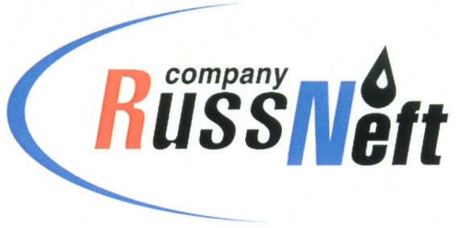
PJSC “RUSSNEFT”
PRESS SERVICE

Tel.: (495) 411-63-24; (495) 411-63-21  Fax: (495) 411-63-19  E-mail: pr@russneft.ru  www.russneft.ru | 115054, Moscow,  Pyatnitskaya str., 69

PRESS - RELEASE
March 11, 2024
Children of sponsored Neftyanik FC successfully performed at interregional competitions

The Football Club created under the patronage of PJSC “RussNeft”, has successfully performed at the Interregional mini-football tournament dedicated to the Defender of the Motherland Day.
The tournament was held in the village of Nikolaevka, Ulyanovsk region. The football club children reached the finals, where they met with athletes from the Penza region. The young football players, having played 1:1 in regular time, lost to their opponents in a penalty shootout and took 2nd place.
Neftyanik girls' team, as the winner of the regional phase of the all-Russian project "Mini-football to school", represented the Ulyanovsk region in the finals of the All-Russian competitions. In their division of 16 winning teams from various regions of Russia, Neftyanik girls took 4th place. And this is a great success!
The Neftyanik Football Club was founded in 2003 in the Novospasskoye working settlement of the Novospassky district of Ulyanovsk region, with the support of RussNeft. More than 200 children aged 7 - 17 are trained in the club.

About the Company:
PJSC “RussNeft” ranks among the top 10 largest oil companies by crude oil production in Russia.
The Company possesses a well-balanced portfolio of assets located in the key Russian oil and gas provinces (West Siberia, Volga-Urals and Central Siberia) as well as in Azerbaijan.
The headcount of the Company is around 8,000 employees.

Press Service of PJSC "RussNeft"
Phone: (495) 411-63-24
Fax: (495) 411-63-19
E-mail: pr@russneft.ru

