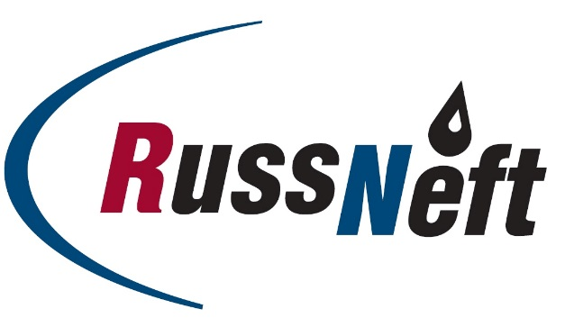
PJSC “RUSSNEFT” PRESS SERVICE

Tel.: (495) 411-63-24; (495) 411-63-21  Fax: (495) 411-63-19  E-mail: pr@russneft.ru  www.russneft.ru | 115054, Moscow,  Pyatnitskaya str., 69

PRESS RELEASE
November 6, 2018

Ministry of education of Saratov Region awards RussNeft

PJSC “RussNeft” has received an award for organizing recreation of children in Saratov region.
The region’s ministry of education named the “Rovesnik” children`s camp owned by Saratovneftegas subsidiary, as the winner in the nomination “The Best Year-Round Healthcare and Recreational Institution for Children”.
The Company pays particular attention to the wellness and awareness raising programmes for the younger generation. Over a number of years, RussNeft together with SAFMAR charity foundation owned by Mikhail Gutseriev has supported organization and conduct of sport competition (Spartakiad) for Saratov children with disabilities. In 2018, the 18th
Open Regional Sport Competition for students of “Rehabilitation and Physical Education” junior sports and adaptive school was held at Rovesnik, hosting more than 200 children with disabilities.
In 2018, for the third time, Rovesnik held a traditional session under a slogan “We are children of the space!” attributed to the Space Exploration Day. Over 250 school children from Engelsky and Rovensky municipalities of Saratov region, as well as students of the pedagogical college of Gagarin Saratov State Technical University could usefully recreate in Rovesnik during one week. Talents show, patriotic songs festival, “Per aspera ad astra” philatelic initiative, robotechnics innovation exhibition, handcraft contests, flash mobs, quizzes, hobby groups, night fires and discos were some of the activities children were involved in.
This year, more than 140 pupils of Saratov Regional Centre for supporting gifted children have recreated in the health improvement camp. Special thematic program was developed for them including active recreation, plein air, exhibitions, concerts, mater classes and open lessons given by renown culture people, professors and docents from universities and vocational schools of Saratov region and other areas of Russia and Moscow.
This is not all that was done for the year.

About the Company:

PJSC “RussNeft” ranks among the Top-10 largest oil companies by crude oil production in Russia.
The Company possesses a well-balanced portfolio of assets located in the key Russian oil and gas provinces (West Siberia, Volga-Urals and Central Siberia) as well as in Azerbaijan.
The Company’s 2P reserves exceed 200 mln tons (SPE). The number of the Company’s personnel is around 10,000.

PJSC “RussNeft” Press Service
Tel.: (495) 411-63-24, Fax: (495) 411-63-19
E-mail: pr@russneft.ru

