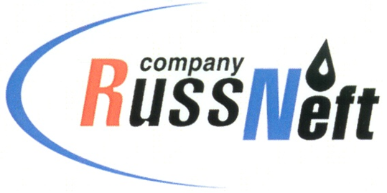
PJSC “RUSSNEFT” PRESS SERVICE

Tel.: (495) 411-63-24; (495) 411-63-21  Fax: (495) 411-63-19  E-mail: pr@russneft.ru  www.russneft.ru | 115054, Moscow,  Pyatnitskaya str., 69

PRESS RELEASE
January 22, 2019

RussNeft increases its reserves by 40 million tonnes in 2018

PJSC “RussNeft” oil reserves growth amounted to 39.6 million tonnes in 2018. The bulk of geological exploration works in the reporting year was done in Khanty-Mansi Autonomous Okrug.
Every year the Company implements the extensive exploration programme, and the main focus areas of the oil reserves addition are the unconventional and hard-to-recover oil reserves. It enables the swift ranking of the projects, highlighting the most attractive and promising ones (Verkhne-Shapshinskoye, Tagrinskoye, Zapadno-Varioganskoye oilfields).
In 2018, the 3D CDP field seismic exploration works were completed at the licence areas of Shapshinskaya Group of fields. The total volume of seismic exploration works exceeds 1600 km2. Complex processing and re-interpretation of seismic and well data for Shapshinskaya Group have been fulfilled, helping to update the geological model of the Neocomian deposits.
As part of the exploration and appraisal stage, the following works are being performed: preparations for 3D seismic survey at Vodorazdelny licence; processing and re-interpretations of the 2D CDP seismic data for Khantymansiysko-Frolovsky subsoil area of KhMAO-Yugra in order to find new deposits in pre-Jurassic and Neocomian formations; active preparations for exploration and appraisal drilling at Soboliny licence area of Tomsk Region.

About the Company:
PJSC “RussNeft” ranks among the Top-10 largest oil companies by crude oil production in Russia.
The Company possesses a well-balanced portfolio of assets located in the key Russian oil and gas provinces (West Siberia, Volga-Urals and Central Siberia), as well as in Azerbaijan.
The number of the Company’s personnel is around 10,000.

PJSC “RussNeft” Press Service
Tel.: (495) 411-63-24, Fax: (495) 411-63-19
E-mail: pr@russneft.ru

