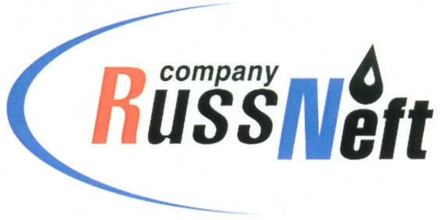
PJSC “RUSSNEFT”
PRESS SERVICE

Tel.: (495) 411-63-24; (495) 411-63-21  Fax: (495) 411-63-19  E-mail: pr@russneft.ru  www.russneft.ru | 115054, Moscow,  Pyatnitskaya str., 69

PRESS - RELEASE
July 25, 2023
RussNeft signs a social partnership agreement with Nizhnevartovsk administration

Nizhnevartovsk branch of PJSC “RussNeft” has entered into a social partnership agreement with the city administration of Nizhnevartovsk. The Company's funds are spent for the implementation of socially significant city events.
Socio-economic agreements between RussNeft and the city administration have been concluded on an annual basis since 2010. Throughout the period of cooperation, the company donated more than RUB 18 mln to implement financial support programs for educational institutions, as well as for public organizations.
This year, the Company has allocated RUB 0.6 mln to the city administration for the implementation of social projects.

About the Company:
PJSC “RussNeft” ranks among the top-10 largest oil companies by crude oil production in Russia.
The Company possesses a well-balanced portfolio of assets located in the key Russian oil and gas provinces (West Siberia, Volga-Urals and Central Siberia) as well as in Azerbaijan.
The headcount of the Company is around 8,000 employees.

Press Service of PJSC "RussNeft"
Phone: (495) 411-63-24
Fax: (495) 411-63-19
E-mail: pr@russneft.ru

