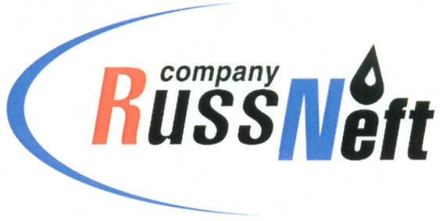
PJSC “RUSSNEFT” PRESS SERVICE

Tel.: (495) 411-63-24; (495) 411-63-21  Fax: (495) 411-63-19  E-mail: pr@russneft.ru  www.russneft.ru | 115054, Moscow,  Pyatnitskaya str., 69

PRESS RELEASE
November 3, 2020

FC Neftyanik, sponsored by PJSC “RussNeft”, became a silver medalist at the All-Russian tournament "Leather Ball".

The girls' team of FC Neftyanik, sponsored by PJSC “RussNeft”, (Novospasskoye work settlement, Ulyanovsk region) won a silver medal at the all-Russian football competition among children's teams "Leather ball".
The team Neftyanik, sponsored by PJSC “RussNeft”, represented the Ulyanovsk region in the final of all-Russian competitions in Smolensk, in which 16 best children's teams of Russia took part.
In its age group the team Neftyanik confidently defeated its peers from Volgograd region with the score 2:1, from Moscow region with the score 5:0, from Makhachkala with the score 26:0 and reached the semifinals, where it met with the team from Ekaterinburg, which was beaten with the score 1:0.
In the final of the tournament Neftyanik lost first place to the team Slavator (Leningrad region) in the penalty shootout series.
Trainees of FC Neftyanik became silver prizewinners of the tournament. No team from the Ulyanovsk region has achieved such high results. The best player of the tournament was recognized as Yana Helvikh, the best goalscorer - Victoria Kalmykova.
FC Neftyanik was founded in 2003 with the support of the founder and owner of “RussNeft” Mikhail Gutseriev.

About Company:y:
PJSC “RussNeft” ranks among the top-10 largest oil companies by crude oil production in Russia.
The Company possesses a well-balanced portfolio of assets located in the key Russian oil and gas provinces (West Siberia, Volga-Urals and Central Siberia) as well as in Azerbaijan.
The headcount of the Company is around 10,000 employees.

Press Service of PJSC "RussNeft"
Phone: (495) 411-63-24, Fax: (495) 411-63-19
E-mail: pr@russneft.ru

