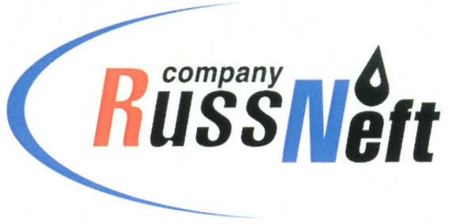
PJSC “RUSSNEFT”
PRESS SERVICE

Tel.: (495) 411-63-24; (495) 411-63-21  Fax: (495) 411-63-19  E-mail: pr@russneft.ru  www.russneft.ru | 115054, Moscow,  Pyatnitskaya str., 69

PRESS - RELEASE
August 31, 2023
RussNeft complies with its social partnership obligations in Nizhnevartovsk District of KhMAO

Nizhnevartovsk branch of PJSC “RussNeft” has met obligations under socio-economic agreement with Nizhnevartovsk district administration.
This year, the Company`s contribution to the district social development amounted to RUB 5.6 млн. The funds were used for completion of renovation of the Church of the Holy Martyr Hermogenes and All the New Martyrs and Confessors of the Russian Church in the urban settlement of Novoagansk, as well as for the construction completion of the temple complex in the village of Laryak.
RussNeft continues to maintain active work with the municipalities of Yugra on the implementation of socially significant programs in the territories where the Company operates.
Socio-economic partnership between RussNeft and the municipalities of the Khanty-Mansiysk Autonomous Region started in 2010.

About the Company:
PJSC “RussNeft” ranks among the top-10 largest oil companies by crude oil production in Russia.
The Company possesses a well-balanced portfolio of assets located in the key Russian oil and gas provinces (West Siberia, Volga-Urals and Central Siberia) as well as in Azerbaijan.
The headcount of the Company is around 8,000 employees.

Press Service of PJSC "RussNeft"
Phone: (495) 411-63-24
Fax: (495) 411-63-19
E-mail: pr@russneft.ru

