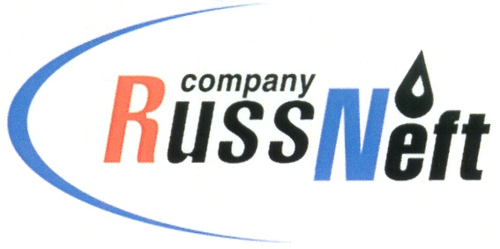

PJSC “RUSSNEFT” PRESS SERVICE

PRESS-RELEASE
Tel.: (495) 411-63-24; (495) 411-63-21  Fax: (495) 411-63-19  E-mail: pr@russneft.ru  www.russneft.ru | 115054, Moscow,  Pyatnitskaya str., 69

PRESS-RELEASE
27 June 2017

Annual General Meeting of Shareholders of PJSC “RussNeft” approved payment of dividends

PJSC “RussNeft” shareholders approved the annual statement and financial statements of the Company for 2016 at the Annual General Meeting of Shareholders held in Moscow on June 27.
The Meeting approved the profit distribution and agreed with the proposal of the Board of Directors to allocate $39,999,996.96 for payment of dividends on the cumulative preference shares of the Company. RUB 4,804,000 were allocated to the reserve fund.
According to the decision of the Meeting of Shareholders, PJSC “RussNeft” dividends on the cumulative preference shares, following the 2016 results, will be paid in monetary form based on $0.40803 per share (as per the Bank of Russia currency exchange rate on the date of the dividends actual payment).
The shareholders approved July 17, 2017, as the record date of the persons entitled for the dividends.
The Meeting of Shareholders elected the new Board of Directors of the Company which includes: Mikhail Safarbekovich Gutseriev, Said Mikhailovich Gutseriev, Sait-Salam Safarbekovich Gutseriev, Mikail Osmanovich Shishkhanov, Avet Vladimirovich Mirakyan, Andrey Leonidovich Zarubin, Dmitry Vyacheslavovich Romanov, Andrey Mikhailovich Derekh, Viktor Geogiyevich Martynov, Robert Jacob Alexander Skidelsky, Sergey Vadimovich Stepashin, Vladimir Lvovich Scherbak, Yana Robertovna Tikhonova.
The Meeting also approved BDO Unicon for the 2017 mandatory audit and Ernst & Young for the consolidated financial statements audit.

About the Company:
PJSC “RussNeft” ranks among the Top-6 largest oil companies by crude oil production in Russia.
The Company possesses a well-balanced portfolio of assets located in key Russian oil&gas provinces (West Siberia, Volga-Urals and Central Siberia) as well as in Azerbaijan.
Total 2P reserves of the Company exceed 200 million tonnes (SPE). The number of the Company’s employees is around 10,000.

PJSC “RussNeft” Press Service
Tel.: (495) 411-63-24, Fax: (495) 411-63-19
E-mail: pr@russneft.ru

