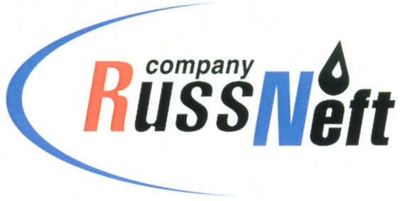
PJSC “RUSSNEFT” PRESS SERVICE

Tel.: (495) 411-63-24; (495) 411-63-21  Fax: (495) 411-63-19  E-mail: pr@russneft.ru  www.russneft.ru | 115054, Moscow,  Pyatnitskaya str., 69

PRESS - RELEASE
September 5, 2022
RussNeft continues to implement cultural tradition development programs of Ugra indigenous people

PJSC RussNeft took part in charity programs focusing on promoting the unique culture and traditional economic activities of the indigenous peoples of the Khanty-Mansi Autonomous Okrug - Yugra. RUB 450 thousand have been allocated for the implementation of social projects in 2022.

The Nizhnevartovsk branch of RussNeft produces hydrocarbons on lands belonging to traditional nature use territories of more than 60 families of the indigenous minorities of the North. The preservation of the culture, traditions and customs of the indigenous inhabitants of Ugra is one of the main areas of the Company's social projects.

Financial and charitable assistance was provided to organizations whose activities are aimed at the revival, preservation and development of folk arts, traditional crafts, ensuring the preservation and continuity in the development of ancient traditions of the indigenous peoples of the North. Among those organizations are the Inter-Settlement Center of National Crafts and Trades in the Agan rural settlement (Nizhnevartovsky district) and the Salvation of Ugra non-governmental organization.

RussNeft is a long-term sponsor in organizing and holding of the indigenous peoples folk festivals, being held annually in the settlements of the Nizhnevartovsk district and including the Day of the Hunter and Reindeer Herder, Day of the Gray Crow Arrival, Autumn Festival, etc. Moreover, with the financial support of the Company, a professional skills contest for the Ugra Governor`s Cup among reindeer herders of the district is held.

About the Company:
PJSC “RussNeft” ranks among the top-10 largest oil companies by crude oil production in Russia.
The Company possesses a well-balanced portfolio of assets located in the key Russian oil and gas provinces (West Siberia, Volga-Urals and Central Siberia) as well as in Azerbaijan.
The headcount of the Company is around 8,000 employees.

Press Service of PJSC "RussNeft"
Phone: (495) 411-63-24
Fax: (495) 411-63-19
E-mail: pr@russneft.ru

