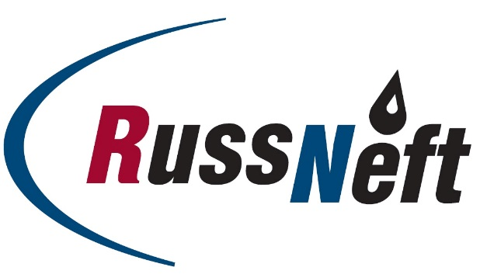
PJSC “RUSSNEFT” PRESS SERVICE

Tel.: (495) 411-63-24; (495) 411-63-21  Fax: (495) 411-63-19  E-mail: pr@russneft.ru  www.russneft.ru | 115054, Moscow,  Pyatnitskaya str., 69

PRESS RELEASE
March 11, 2019

M. Gutseriev discussed with the Minister of culture V. Medinsky the updating of legislation in the field of charity, philanthropy and culture

Chairman of the Board of Directors of PJSC “RussNeft” Mikhail Gutseriev, who heads the Russian Union of Industrialists and Entrepreneurs’ Commission on charity, philanthropy and culture, discussed with the Minister of culture of the Russian Federation Vladimir Medinsky the issues of updating the legal framework in the field of charity, philanthropy and culture.

During the working meeting, the parties identified priority areas of the Commission's work in order to build a constructive dialogue between the government, business and cultural figures.

At the meeting, M. Gutseriev noted the need to involve experts from various ministries and departments, as well as representatives of the business community in the formation of an objective position in the preparation of proposals for the introduction of overdue changes in the legal framework governing the sphere of charity, philanthropy and culture.

About the Company:

PJSC “RussNeft” ranks among the Top-10 largest oil companies by crude oil production in Russia.

The Company possesses a well-balanced portfolio of assets located in the key Russian oil and gas provinces (West Siberia, Volga-Urals and Central Siberia) as well as in Azerbaijan.
The volume of 2P reserves of the Company exceeds 200 million tons (SPE).
2P reserves of the Company exceed 200 million tonnes (SPE).
The number of the Company’s personnel is around 10,000.

PJSC “RussNeft” Press Service
Tel.: (495) 411-63-24, Fax: (495) 411-63-19
E-mail: pr@russneft.ru

