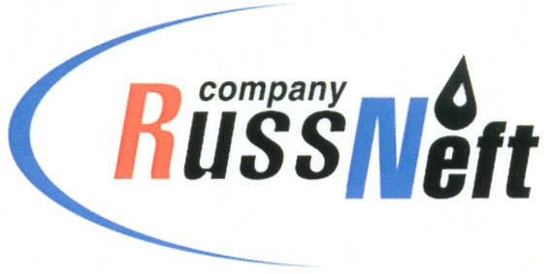

**PJSC “RUSSNEFT” PRESS SERVICE**

|  |  |
| --- | --- |
| **Tel.: (495) 411-63-24; (495) 411-63-21**  **Fax: (495) 411-63-19**  **E-mail: pr@russneft.ru**  [**www.russneft.ru**](http://www.russneft.ru/) | **115054, Moscow,**  **Pyatnitskaya str., 69** |

**PRESS - RELEASE**

**March 3, 2025**

**RussNeft intensifies work with educational institutions**

PJSC “RussNeft” continues to work with educational institutions to attract promising young specialists to the company.

Therefore, the Ulyanovsk branch of the Company introduced the industrial facilities of the enterprise to the students of the Dimitrovgrad Technical College. The young specialists visited the well pad of the Zimnitskoye oil field, where during the tour they got acquainted with the "live" process of well completion, the features of pump jacks, the reservoir pressure maintenance system and pipelines.

In addition, the Ulyanovsk branch cooperates with the Ryazanovsky Agricultural College on the educational program "Development and operation of oil and gas fields", which trains middle level professional staff for the industry. The company provides the college with oil and gas equipment for illustration of technological processes on the training site.

The Saratov branch of RussNeft successfully continues to work on arranging internship for students of the relevant majors of secondary and higher educational institutions of the region. Through participation in Job Fairs, the branch informs young professionals in detail about the benefits of working for the Company: possible social support measures for young professionals and prospects for professional development, including at the Lomonosov Moscow State University Graduate School of Innovative Business.

Within the framework of partnership educational programs, RussNeft has been cooperating for many years with Moscow State University, where the corporate university "Higher School of Innovative Business of Moscow State University" operates with the active assistance of the Company. The Faculty has already prepared 14 master's graduating classes, and also conducts advanced training courses for RussNeft personnel on an annual basis.

**About the Company:**

PJSC “RussNeft” ranks among the top-10 largest oil companies by crude oil production in Russia.

The Company possesses a well-balanced portfolio of assets located in the key Russian oil and gas provinces (West Siberia, Volga-Urals and Central Siberia).

The headcount of the Company is around 7,000 employees.

**Press Service of PJSC "RussNeft"**

**Phone: (495) 411-63-24,**

**Fax: (495) 411-63-19**

**E-mail:**[**pr@russneft.ru**](mailto:pr@russneft.ru)