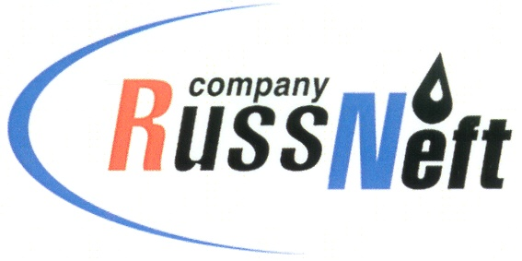
PJSC “RUSSNEFT”
PRESS SERVICE

Tel.: (495) 411-63-24; (495) 411-63-21  Fax: (495) 411-63-19  E-mail: pr@russneft.ru  www.russneft.ru | 115054, Moscow,  Pyatnitskaya str., 69

PRESS - RELEASE
June 14, 2024
RussNeft sponsors Nizhnevartovsk Arts Festival

PJSC “RussNeft” provided sponsorship for the celebration of the Nizhnevartovsk District Establishment Day.
The Nizhnevartovsk branch of the Company, within the framework of an agreement with the municipality, allocated funds for organizng the 96th anniversary of the district founding and holding of the arts festival "My Heart is Nizhnevartovsk district".
In addition, RussNeft is a regular sponsor of the national holidays of indigenous people of Yugra, namely "Day of Arrival of the Gray Crow", "Day of Oblas Boat", "Day of the Hunter and Reindeer herder" and "Autumn Holiday".
In the near term, RussNeft intends to continue working closely with Nizhnevartovsk district administration to implement programs of public importance in the areas of the Company's operations.

About the Company:
PJSC “RussNeft” ranks among the top-10 largest oil companies by crude oil production in Russia.
The Company possesses a well-balanced portfolio of assets located in the key Russian oil and gas provinces (West Siberia, Volga-Urals and Central Siberia) as well as in Azerbaijan.
The headcount of the Company is around 7,000 employees.

Press Service of PJSC "RussNeft"
Phone: (495) 411-63-24
Fax: (495) 411-63-19
E-mail: pr@russneft.ru

