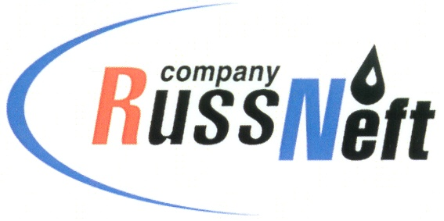
PJSC “RUSSNEFT”
PRESS SERVICE

Tel.: (495) 411-63-24; (495) 411-63-21  Fax: (495) 411-63-19  E-mail: pr@russneft.ru  www.russneft.ru | 115054, Moscow,  Pyatnitskaya str., 69

PRESS - RELEASE
June 5, 2023
RussNeft has participated in Garden of Memory international event

Employees of the Khanty-Mansiysk branch of PJSC “RussNeft” took part in the Garden of Memory traditional memorial action. Its goal is to create 27 million “green monuments” to those deceased during the Great Patriotic War.
The Garden of Memory campaign has been held in Khanty-Mansiysk JSC since 2020 in the framework of the Forest Conservation federal project being the part of the Ecology national project. This year, the afforestation took place on the territory of the Samarovskoye forestry. In total, Khanty-Mansiysk residents planted about three thousand pine seedlings, and this year afforestation took place on an area of 0.7 hectares.
The Khanty-Mansiysk branch of RussNeft was one of the first to join the memory campaign.

About the Company:
PJSC “RussNeft” ranks among the top-10 largest oil companies by crude oil production in Russia.
The Company possesses a well-balanced portfolio of assets located in the key Russian oil and gas provinces (West Siberia, Volga-Urals and Central Siberia) as well as in Azerbaijan.
The headcount of the Company is around 8,000 employees.

Press Service of PJSC "RussNeft"
Phone: (495) 411-63-24
Fax: (495) 411-63-19
E-mail: pr@russneft.ru

