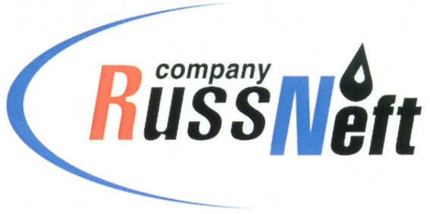

**PJSC “RUSSNEFT” PRESS SERVICE**

|  |  |
| --- | --- |
| **Tel.: (495) 411-63-24; (495) 411-63-21**  **Fax: (495) 411-63-19**  **E-mail: pr@russneft.ru**  [**www.russneft.ru**](http://www.russneft.ru/) | **115054, Moscow,**  **Pyatnitskaya str., 69** |

**PRESS RELEASE**

**January 30, 2025**

**RussNeft informs about fraudulent activities on the Internet**

PJSC “RussNeft” informs about illegal use of the name of the Company, its branches or organizations within its corporate structure, as well as posting of false information about recruitment on their behalf.

Website ruvahta.ru was found on the Internet with job vacancies for production locations of RussNeft.

There have also been personnel selection ads posted in messengers by Avtotrans as if acting on behalf of RussNeft.

The company is related neither to the above-mentioned website, nor to its chatbot with ads, nor to the messages posted in messengers by Avtotrans or other organizations with similar names.

PJSC “RussNeft” declares that representatives of the ruvahta.ru website, the Avtoplus chatbot, the Avtotrans company, as well as individuals who are unlawfully conducting negotiations on behalf of RussNeft regarding the selection of personnel for vacant positions, do not actually have such authority and may pursue fraudulent goals. RussNeft is not liable for commercial offers, transactions, or other obligations of the specified entities and individuals.

In case of doubts about the legitimacy of any personnel recruitment on behalf of PJSC “RussNeft”, please seek clarification at the official addresses of the Company: russneft@russneft.ru, security@russneft.ru.

Should there be any fraud committed against you as a result of any illegal use of the name of the Company, its branches or organizations, please contact law enforcement bodies.

**About the Company:**

PJSC “RussNeft” ranks among the top 10 largest oil companies by crude oil production in Russia.

The Company possesses a well-balanced portfolio of assets located in the key Russian oil and gas provinces (West Siberia, Volga-Urals and Central Siberia).

The headcount of the Company is around 7,000 employees.

**Press Service of PJSC "RussNeft"**

**Phone: (495) 411-63-24, Fax: (495) 411-63-19**

**E-mail:**[**pr@russneft.ru**](mailto:pr@russneft.ru)