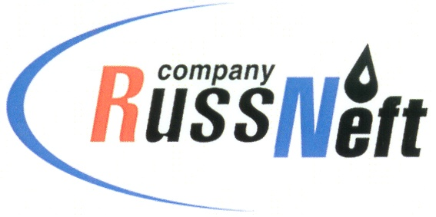
PJSC “RUSSNEFT” PRESS SERVICE

Tel.: (495) 411-63-24; (495) 411-63-21  Fax: (495) 411-63-19  E-mail: pr@russneft.ru  www.russneft.ru | 115054, Moscow,  Pyatnitskaya str., 69

PRESS RELEASE
July 18, 2025

RussNeft replenished the rivers of the Khanty-Mansiysk Autonomous Okrug with bioresources

PJSC “RussNeft” replenished the Ob River basin with fish resources by releasing 1.1 million fry.

The release of young nelma and muksun into the reservoir is carried out by the Tyumen branch of the All-Russian Research Institute of Fisheries and Oceanography under the supervision of the State Commission of the Lower Ob Territorial Administration of the Federal Agency for Fisheries. The volume of RussNeft's investments in stocking the Ob-Irtysh fishery basin in 2025 amounted to 76.5 million rubles.

Annual compensation for damage to aquatic biological resources and their habitat in oil production regions allows for the systematic restoration of aquatic biological resources affected by the development of Western Siberian fields.

About the Company:

PJSC “RussNeft” ranks among the top-10 largest oil companies by crude oil production in Russia.
The Company possesses a well-balanced portfolio of assets located in the key Russian oil and gas provinces (West Siberia, Volga-Urals and Central Siberia).
The headcount of the Company is around 7,000 employees.

PJSC “RussNeft” Press Service
Tel.: (495) 411-63-24,
Fax: (495) 411-63-19
E-mail: pr@russneft.ru

