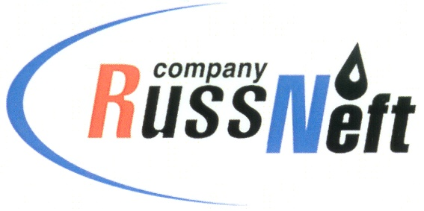
PJSC “RUSSNEFT” PRESS SERVICE

Tel.: (495) 411-63-24; (495) 411-63-21  Fax: (495) 411-63-19  E-mail: pr@russneft.ru  www.russneft.ru | 115054, Moscow,  Pyatnitskaya str., 69

PRESS - RELEASE
October 20, 2025

RussNeft continues to attract young professionals to the Company

PJSC “RussNeft” continues its systematic work with educational institutions to attract young specialists to the Company's branches.

For example, the Ulyanovsk branch regularly holds meetings with students from regional educational institutions, where they are introduced to the branch's structure and employment opportunities, support measures for young employees, and opportunities for on-the-job training and internships.

Particular attention is paid to educational institutions that train mid-level specialists for the region's oil production industry. These include the Ulyanovsk Electromechanical College, Dimitrovgrad Technical College, Ryazan Agricultural College, Ulyanovsk Railway Transport College, P. Machnev Construction and Energy College, and the Samara and Syzran Polytechnic Colleges.

In its HR work, the Ulyanovsk branch practices concluding contracts with promising students from secondary vocational educational institutions, who are guaranteed jobs in their field upon completion.

Based on industry needs, the Company is initiating the creation of in-demand training programs within secondary vocational educational institutions. For example, the Ulyanovsk Railway Technical School is expected to launch a program in "Development and Operation of Oil and Gas Fields."

The Ulyanovsk branch of RussNeft has a social support program for young professionals, including rental compensation, employer-sponsored professional development, and support for research activities.

Young professionals participate in the Young Professionals Council, whose members are involved in scientific and technical conferences and international forums.

About the Company:

PJSC “RussNeft” ranks among the top-10 largest oil companies by crude oil production in Russia.

The Company possesses a well-balanced portfolio of assets located in the key Russian oil and gas provinces (West Siberia, Volga-Urals and Central Siberia).

The headcount of the Company is over 6,000 employees.

Press Service of PJSC "RussNeft"
Phone: (495) 411-63-24, Fax: (495) 411-63-19
E-mail: pr@russneft.ru

