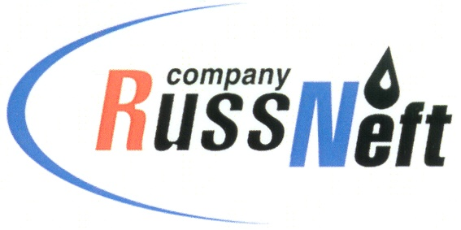
PJSC “RUSSNEFT” PRESS SERVICE

Tel.: (495) 411-63-24; (495) 411-63-21  Fax: (495) 411-63-19  E-mail: pr@russneft.ru  www.russneft.ru | 115054, Moscow,  Pyatnitskaya str., 69

PRESS RELEASE
March 19, 2026

RussNeft's innovators implement about 700 new projects into the corporate production process

The program of optimizing production costs of PJSC “RussNeft” through the implementation of about 700 projects brought the Company an actual economic effect in the amount of RUB 2.4 bln.
In 2025, the Scientific and Technical Board of RussNeft reviewed and recommended for application 41 new projects in various areas of the Company's operation activities. These areas include repair of existing wells, energy efficiency and production engineering, treatment and transportation of oil and gas, optimization of facilities construction, as well as of HSE, introduction of elements of lean production culture, and others.
The corporate optimization program has been operating at RussNeft for over 9 years. Its primary goal is to reduce production costs through innovative initiatives by involving a broad range of employees.

About the Company:

PJSC “RussNeft” ranks among the top-10 largest oil companies by crude oil production in Russia.
The Company possesses a well-balanced portfolio of assets located in the key Russian oil and gas provinces (West Siberia, Volga-Urals and Central Siberia).
The headcount of the Company is around 6,000 employees.

PJSC “RussNeft” Press Service
Tel.: (495) 411-63-24,
Fax: (495) 411-63-19
E-mail: pr@russneft.ru

