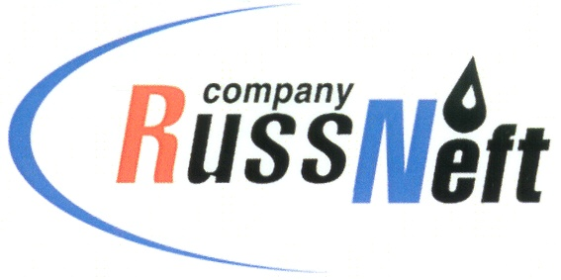
PJSC “RUSSNEFT” PRESS SERVICE

Tel.: (495) 411-63-24; (495) 411-63-21  Fax: (495) 411-63-19  E-mail: pr@russneft.ru  www.russneft.ru | 115054, Moscow,  Pyatnitskaya str., 69

PRESS - RELEASE
October 15, 2025

Seniors had a rest at the Rovesnik health center in Saratov

PJSC “RussNeft” continues its tradition of supporting charitable projects for the senior people.

To mark the International Day of Older Persons, the Company's Saratov branch, together with the regional Ministry of Labor and Social Protection, held the "Silver Age" charity event: over 100 seniors from Saratov and rural municipal districts of the region had a rest at the Rovesnik health center.

This project aims to improve the social status of senior people and promote active ageing and a healthy lifestyle. As per tradition, members of the Saratovneftegaz veterans' organization were given a special place among the guests.

The Ministry of Labor and Social Protection of the Saratov Region once again emphasized the importance and significance of this project and thanked RussNeft for its long-standing support.

About the Company:

PJSC “RussNeft” ranks among the top-10 largest oil companies by crude oil production in Russia.
The Company possesses a well-balanced portfolio of assets located in the key Russian oil and gas provinces (West Siberia, Volga-Urals and Central Siberia).
The headcount of the Company is around 6,000 employees.

Press Service of PJSC "RussNeft"
Phone: (495) 411-63-24, Fax: (495) 411-63-19

