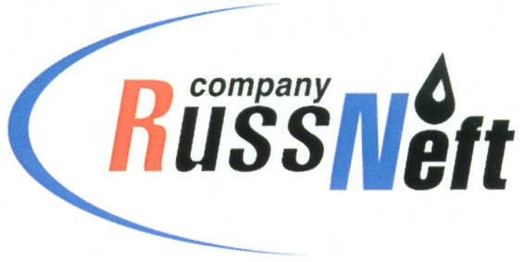

**PJSC “RUSSNEFT” PRESS SERVICE**

|  |  |
| --- | --- |
| **Tel.: (495) 411-63-24; (495) 411-63-21**  **Fax: (495) 411-63-19**  **E-mail: pr@russneft.ru**  [**www.russneft.ru**](http://www.russneft.ru/) | **115054, Moscow,**  **Pyatnitskaya str., 69** |

**PRESS RELEASE**

**March 25, 2019**

**Introduction of RussNeft employees` ideas delivers benefits of over RUB 200 mln**

For the second consecutive year, the Production Costs Optimisation Programme has been successfully operated by the Company and its subsidiaries. As a result, a database of considered ideas is gradually formed and updated, the expertise in implementation of technical measures, organizational and administrative solutions are accumulated.

Within the programme framework, the corporate contest among authors and collectives is held, giving to the ambitious workers the opportunity to demonstrate their potential. The ideas of the holding`s employees focus on one of the major challenges of a business – reduction of operating costs. In March, RussNeft named the winners among the authors and the Entities. Khanty-Mansiysk Branch of the Company was recognized as the winner in the category “The Collective of the Year 2018”.

It should be noted that the Company has well-functioning system of new ideas support. All proposals are considered at the Scientific and Technical Council of RussNeft. In 2018, the Council approved 82 new ideas generated by the employees, for their introduction. Actual effect of their implementation rose by almost 25% over the previous year and reached RUB 208 mln.

**About the Company:**

PJSC “RussNeft” ranks among the Top-10 largest oil companies by crude oil production in Russia.

The Company possesses a well-balanced portfolio of assets located in the key Russian oil and gas provinces (West Siberia, Volga-Urals and Central Siberia) as well as in Azerbaijan.

2P reserves of the Company exceed 200 million tonnes (SPE). The number of the Company’s personnel is around 10,000.

**PJSC “RussNeft” Press Service**

**Tel.: (495) 411-63-24, Fax: (495) 411-63-19**

**E-mail: pr@russneft.ru**