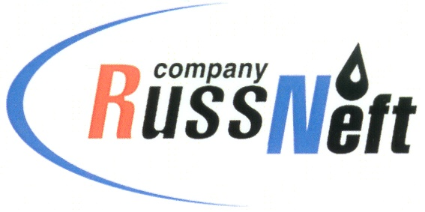
PJSC “RUSSNEFT”
PRESS SERVICE

Tel.: (495) 411-63-24; (495) 411-63-21  Fax: (495) 411-63-19  E-mail: pr@russneft.ru  www.russneft.ru | 115054, Moscow,  Pyatnitskaya str., 69

PRESS - RELEASE
July 9, 2024
RussNeft replenishes biological resources of KhMAO Rivers

RussNeft has replenished the Ob River basin fish resources, having released 3.570 mln. Whitefish (muksun) fry and 408 thous. Siberian white salmon (nelma) fry.
The release of fry into the reservoir is carried out by the Tyumen branch of the All-Russian Scientific Research Institute of Fisheries and Oceanography under the supervision of the State Commission of the Nizhneobskoye Territorial Administration of the Federal Agency for Fisheries. The volume of RussNeft investments in the fish stocking of the Ob-Irtysh fishery basin amounted to more than RUB 46 mln. in 2024.
Annual compensation for the damage to aquatic biological resources and their habitat in the oil production regions makes it possible to systematically restore aquatic biological resources affected by the development of fields in Western Siberia.
In addition, in 2024, the Company increased the area of reforestation by 264 hectares, planting more than 1 mln. transplants. When reproducing forests, RussNeft uses improved and certified seeds of forest plants adapted to the regional specificities of the planting site. To restore forests in Western Siberia, pine seedlings previously grown in nurseries up to a height of 12-20 cm, are normally used. The reforestation program is implemented in the territories designated by forestry to compensate for deforestation at oil production infrastructure construction sites. RussNeft pays close attention to compliance with environmental laws and prevention of the negative environmental impact of production activities.

About the Company:
PJSC “RussNeft” ranks among the top-10 largest oil companies by crude oil production in Russia.
The Company possesses a well-balanced portfolio of assets located in the key Russian oil and gas provinces (West Siberia, Volga-Urals and Central Siberia).
The headcount of the Company is around 7,000 employees.

Press Service of PJSC "RussNeft"
Phone: (495) 411-63-24
Fax: (495) 411-63-19
E-mail: pr@russneft.ru

