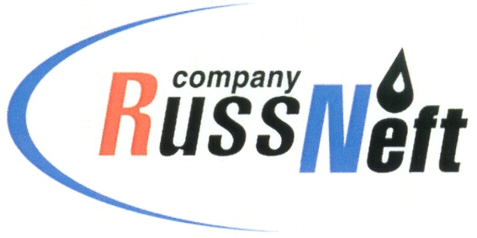
PJSC “RUSSNEFT” PRESS SERVICE

Tel.: (495) 411-63-24; (495) 411-63-21  Fax: (495) 411-63-19  E-mail: pr@russneft.ru  www.russneft.ru | 115054, Moscow,  Pyatnitskaya str., 69

PRESS RELEASE
June 9, 2026

RussNeft continues to support children's creative initiatives

PJSC “RussNeft” continues to support socially significant projects in the regions.

In Saratov, the now-traditional "Volga Rainbow 2026" project was launched at the Rovesnik Health Center under the Company's auspices.

This year, the creative team offered children from the Saratov Region classes in seven areas: theater arts; instrumental performance - wind and percussion instruments; instrumental performance - string instruments; instrumental performance - folk instruments; folklore; choral singing; and fine arts.

The "Volga Rainbow" project is implemented by the Regional Center for Gifted Children Support of the Saratov Regional Educational and Methodological Center in collaboration with the regional Ministry of Culture.

The Volga Rainbow project is a program of deep immersion of children in the world of culture and art under the guidance of industry professionals.

About the Company:
PJSC “RussNeft” ranks among the top-10 largest oil companies by crude oil production in Russia.
The Company possesses a well-balanced portfolio of assets located in the key Russian oil and gas provinces (West Siberia, Volga-Urals and Central Siberia).
The headcount of the Company is around 6,000 employees.

Press Service of PJSC "RussNeft"
Phone: (495) 411-63-24, Fax: (495) 411-63-19
E-mail: pr@russneft.ru

