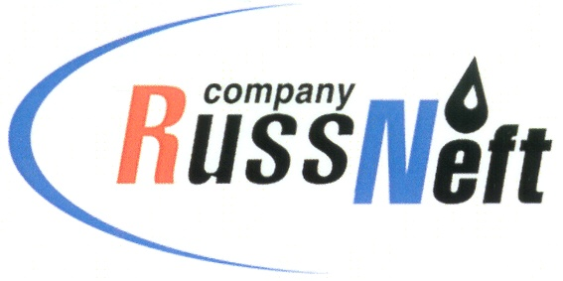
PJSC “RUSSNEFT” PRESS SERVICE

Tel.: (495) 411-63-24; (495) 411-63-21  Fax: (495) 411-63-19  E-mail: pr@russneft.ru  www.russneft.ru | 115054, Moscow,  Pyatnitskaya str., 69

PRESS RELEASE
September 12, 2021

RussNeft receives awards at the Black Gold of Yugra competition

Branches of PJSC “RussNeft” have been named the winners of the annual regional competition Black Gold of Yugra.
The Nizhnevartovsk branch of the Company became the winner in the nomination "For social and economic partnership among the companies with the annual production output of up to 5 mt of oil". The Khanty-Mansiysk branch took the third place in the nomination "The most dynamically developing enterprise with an annual production output of up to 5 mt of oil." The jury praised the contribution of the branches to the economic and social development of the districts and Khanty-Mansiysk Autonomous Okrug as a whole.
In addition, employees of the enterprises were awarded diplomas as winners of the competition in personal nominations. The Black Gold of Yugra competition, constituted by the government of the Okrug, is traditionally held in conjunction with the Oil and Gas Industry Workers Day. Every year, companies involved in the extraction of hydrocarbons in the Khanty-Mansiysk Autonomous Okrug take part in it.

About the Company:

PJSC “RussNeft” ranks among the top-10 largest oil companies by crude oil production in Russia.
The Company possesses a well-balanced portfolio of assets located in the key Russian oil and gas provinces (West Siberia, Volga-Urals and Central Siberia).
The headcount of the Company is around 7,000 employees.

PJSC “RussNeft” Press Service
Tel.: (495) 411-63-24
Fax: (495) 411-63-19
E-mail: pr@russneft.ru

