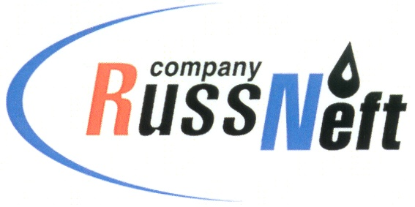
PJSC “RUSSNEFT” PRESS SERVICE

Tel.: (495) 411-63-24; (495) 411-63-21  Fax: (495) 411-63-19  E-mail: pr@russneft.ru  www.russneft.ru | 115054, Moscow,  Pyatnitskaya str., 69

PRESS - RELEASE
August 15, 2025

RussNeft to support documentary drama film festival in Saratov

PJSC “RussNeft” will support the film festival in Saratov, which this year is dedicated to the 90th anniversary of Oleg Tabakov.

With the support of the Saratov branch of the company, the Saratov Sufferings International Film Festival of Documentary Drama, at the origins of which stood the People's Artist of the USSR Oleg Tabakov, will take place at the end of August. The festival program includes world documentary drama screenings, meet-the-artist-events with directors and actors, master classes from famous documentary filmmakers. In 2025, the event will be held for the 22nd time.

Another event that cannot be dissociated from the name of O.Tabakov is the Tabakov's Lessons project-festival, the initiator and organizer of which is the Saratov Drama Theater. The festival format includes not only performances by the best theaters in the country, but also master classes and discussions for students and teachers of the Saratov Theater Institute.

The name of O.Tabakov is inextricably linked with Saratov: he was born here, spent his childhood and youth, and took his first artistic steps.

RussNeft does not stand aside and supports significant projects related to the memory of the prominent actor and director.

About the Company:
PJSC “RussNeft” ranks among the top-10 largest oil companies by crude oil production in Russia.
The Company possesses a well-balanced portfolio of assets located in the key Russian oil and gas provinces (West Siberia, Volga-Urals and Central Siberia).
The headcount of the Company is around 7,000 employees.

Press Service of PJSC "RussNeft"
Phone: (495) 411-63-24, Fax: (495) 411-63-19
E-mail: pr@russneft.ru

