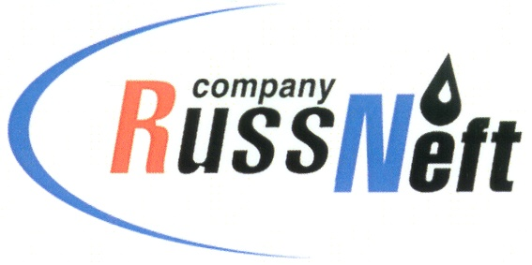

PJSC “RUSSNEFT” PRESS SERVICE

Tel.: (495) 411-63-24; (495) 411-63-21  Fax: (495) 411-63-19  E-mail: pr@russneft.ru  www.russneft.ru | 115054, Moscow,  Pyatnitskaya str., 69

PRESS RELEASE
March 15, 2022

Ulyanovsk branch of RussNeft will provide support to young athletes with disabilities

PJSC "RussNeft" will provide financial support for Ulyanovsk Region Championship in cross-country skiing for children with disabilities.
85 children with disorders of the musculoskeletal system and vision will take part in the competition. Championship dedicated to the Hero of the Soviet Union V.N. Kashtankin, will be held in March and will be the first stage of the Third Regional Children's Paralympic Games, scheduled for July 2022.
Ulyanovsk branch of RussNeft donated charitable funds to Ulyanovsk regional public organization Association for Assistance to Athletes with Disabilities "UNITY" for organizing and holding competitions.

About the Company:
PJSC “RussNeft” ranks among the top-10 largest oil companies by crude oil production in Russia.
The Company possesses a well-balanced portfolio of assets located in the key Russian oil and gas provinces (West Siberia, Volga-Urals and Central Siberia) as well as in Azerbaijan.
The headcount of the Company is around 8,000 employees.

PJSC “RussNeft” Press Service
Tel.: (495) 411-63-24, Fax: (495) 411-63-19
E-mail: pr@russneft.ru

