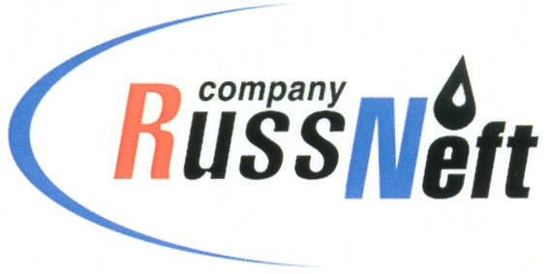

**PJSC “RUSSNEFT” PRESS SERVICE**

|  |  |
| --- | --- |
| **Tel.: (495) 411-63-24; (495) 411-63-21**  **Fax: (495) 411-63-19**  **E-mail: pr@russneft.ru**  [**www.russneft.ru**](http://www.russneft.ru/) | **115054, Moscow,**  **Pyatnitskaya str., 69** |

**PRESS - RELEASE**

**March 21, 2025**

**RussNeft continues to implement joint educational project with Gubkin Oil and Gas University**

PJSC “RussNeft” continues a joint educational project with the Gubkin Oil and Gas University to prepare schoolchildren for the Unified State Exam for successful admission to higher education institutions.

Applicants receive intensive educational training at regional pre-academic programs (RPP), where retreats with schoolchildren are conducted by Gubkin University`s teachers on the basis of the Company's branches. The RPP students include not only children of RussNeft employees, but also high school students who are interested in obtaining additional knowledge in majors.

Apart from preparing for the USE, students take in information about the majors and professions that can be obtained at the Gubkin Oil and Gas University.

One of the strategic objectives of this educational project is to train high-end professionals for further work within RussNeft structure.

All expenses related to the arrangement and conduct of the RPP are borne by the Company. The educational project has been successfully implemented since 2010.

**About the Company:**

PJSC “RussNeft” ranks among the top-10 largest oil companies by crude oil production in Russia.

The Company possesses a well-balanced portfolio of assets located in the key Russian oil and gas provinces (West Siberia, Volga-Urals and Central Siberia) as well as in Azerbaijan.

The headcount of the Company is around 8,000 employees.

**Press Service of PJSC "RussNeft"**

**Phone: (495) 411-63-24,**

**Fax: (495) 411-63-19**

**E-mail:**[**pr@russneft.ru**](mailto:pr@russneft.ru)