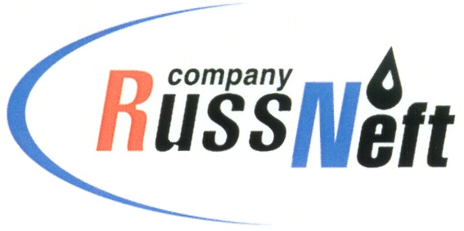
PJSC “RUSSNEFT” PRESS SERVICE

Tel.: (495) 411-63-24; (495) 411-63-21  Fax: (495) 411-63-19  E-mail: pr@russneft.ru  www.russneft.ru | 115054, Moscow,  Pyatnitskaya str., 69

PRESS RELEASE
March 1, 2018

PJSC “RussNeft” completed extension of the gas infrastructure in Saratov region

PJSC “RussNeft” completed upgrade and extension of the gas infrastructure at Belokamennoye field in Saratov region.
Development of the gas business in Saratov region is a priority of the Company.
Construction of the new gas networks and infrastructure allowed to increase the natural gas production at the field up to 70 million cubic meters per annum.
The estimated recoverable reserves at Belokamennoye field are 763 cubic meters of gas and almost 100 thousand tonnes of gas condensate.
When choosing technologies and equipment for the project, the Company prioritized those produced locally in Saratov region.

About the Company:
PJSC “RussNeft” ranks among the Top-10 largest oil companies by crude oil production in Russia.
The Company possesses a well-balanced portfolio of assets located in the key Russian oil and gas provinces (West Siberia, Volga-Urals and Central Siberia) as well as in Azerbaijan.
2P reserves of the Company are over 200 million tonnes (SPE).
The number of the Company’s personnel is around 10,000.

PJSC “RussNeft” Press Service
Tel.: (495) 411-63-24, Fax: (495) 411-63-19
E-mail: pr@russneft.ru

