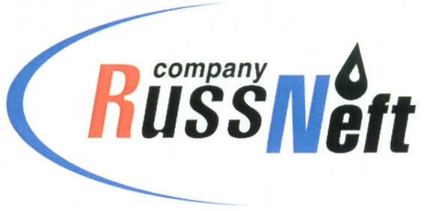
PJSC “RUSSNEFT”
PRESS SERVICE

Tel.: (495) 411-63-24; (495) 411-63-21  Fax: (495) 411-63-19  E-mail: pr@russneft.ru  www.russneft.ru | 115054, Moscow,  Pyatnitskaya str., 69

PRESS - RELEASE
March 20, 2024
RussNeft increases tax payments to Saratov region budget by the factor of 1.6

In 2023, PJSC “RussNeft” completed the restructuring of its assets as part of obligations assumed under the decision of the Company's Board of Directors.
The restructuring of the business implied the transition to a branch management system (without job cuts in the group as a whole). The company also established a branch in Saratov, which took over the functions of oil production.
However, part of the property remained in the structure of PJSC Saratovneftegaz, which has been carrying out business operations for leasing property within the scope of its powers since 2022.
As the Company has previously stated, all core oil production activities were transferred to the branches.
Conducted restructuring of assets resulted in an increase in RussNeft Group`s tax payments to the budget of the Saratov region in 2023 of up to RUB 701 mln, exceeding the similar indicator of 2022 (RUB 439 mln) by 1.6-times.

About the Company:
PJSC “RussNeft” ranks among the top-10 largest oil companies by crude oil production in Russia.
The Company possesses a well-balanced portfolio of assets located in the key Russian oil and gas provinces (West Siberia, Volga-Urals and Central Siberia) as well as in Azerbaijan.
The headcount of the Company is around 8,000 employees.

Press Service of PJSC "RussNeft"
Phone: (495) 411-63-24
Fax: (495) 411-63-19
E-mail: pr@russneft.ru

