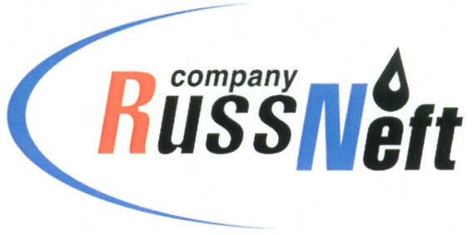
PJSC “RUSSNEFT”
PRESS SERVICE

Tel.: (495) 411-63-24; (495) 411-63-21  Fax: (495) 411-63-19  E-mail: pr@russneft.ru  www.russneft.ru | 115054, Moscow,  Pyatnitskaya str., 69

PRESS - RELEASE
December 12, 2022
PJSC “RussNeft” Allocates RUB 23 Mln to Support the Indigenous Peoples of Yugra

PJSC “RussNeft” allocated above RUB 23.3 mln in 2022 for compensatory payments to the indigenous peoples of the North.

PJSC “RussNeft” branch in Nizhnevartovsk produces hydrocarbons in the Nizhnevartovsk and Surgut districts of KhMAO-Yugra on lands on 10 territories where 59 families of indigenous peoples of the North are engaged in traditional nature management.

Compensatory payments are allocated for the purchase of equipment, construction materials, fuel and other necessary equipment needed in forest camps.

The conclusion of Compensatory Payments Agreements is not the only an example of cooperation between the Company and the indigenous peoples of Yugra. This year, while implementing the program of social and economic development of the territory where the Company operates, PJSC “RussNeft” provided financial support to “Inter-Settlement Center of National Crafts and Arts" (Agan rural settlement, Nizhnevartovsky district), and also acted as a partner and founder of special prizes in the competition of professional skills among district’s reindeer herders for the Prize of Yugra Governor. Professional competitions were held within the framework of the World Congress of Reindeer Herders which took place in Khanty-Mansiysk.
PJSC “RussNeft” will continue to finance programs aimed at supporting and preserving the authentic culture, traditions and customs of the indigenous peoples of Yugra.

About the Company:
PJSC “RussNeft” ranks among the top-10 largest oil companies by crude oil production in Russia.
The Company possesses a well-balanced portfolio of assets located in the key Russian oil and gas provinces (West Siberia, Volga-Urals and Central Siberia) as well as in Azerbaijan.
The headcount of the Company is around 8,000 employees.

Press Service of PJSC "RussNeft"
Phone: (495) 411-63-24
Fax: (495) 411-63-19
E-mail: pr@russneft.ru

