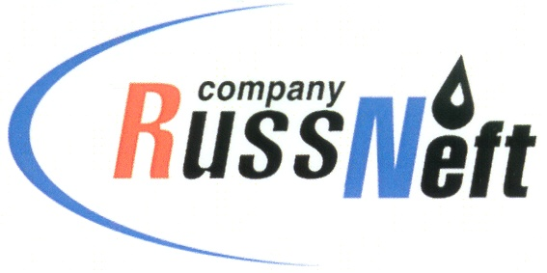
PJSC “RUSSNEFT” PRESS SERVICE

Tel.: (495) 411-63-24; (495) 411-63-21  Fax: (495) 411-63-19  E-mail: pr@russneft.ru  www.russneft.ru | 115054, Moscow,  Pyatnitskaya str., 69

PRESS RELEASE
March 03, 2026

RussNeft enhancing personnel competencies

PJSC “RussNeft” continues to upgrade the professional skills of its employees.
This year, the Ulyanovsk branch continues to actively implement additional vocational training programs. This includes compliance with safety requirements when performing work at height, industrial safety of hazardous production facilities, and occupational safety in terms of training in safe methods and techniques for performing work when exposed to harmful and dangerous industrial factors. The branch's plan includes extensive retraining of specialists in the Chemical Analysis Laboratory Technician program.
The Company's HR department pays great attention to the recruitment. For example, the Saratov branch, in addition to online opportunities, regularly uses job fairs. In 2025, the company was represented at five job fairs organized by city and district employment centers, providing all interested applicants with information about the branch's activities.
Improving personnel competencies remains a key focus of the Company.

About the Company:

PJSC “RussNeft” ranks among the top-10 largest oil companies by crude oil production in Russia.
The Company possesses a well-balanced portfolio of assets located in the key Russian oil and gas provinces (West Siberia, Volga-Urals and Central Siberia).
The headcount of the Company is around 6,000 employees.

PJSC “RussNeft” Press Service
Tel.: (495) 411-63-24,
Fax: (495) 411-63-19
E-mail: pr@russneft.ru

