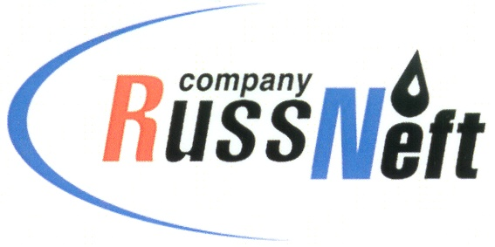
PJSC “RUSSNEFT” PRESS SERVICE

Tel.: (495) 411-63-24; (495) 411-63-21  Fax: (495) 411-63-19  E-mail: pr@russneft.ru  www.russneft.ru | 115054, Moscow,  Pyatnitskaya str., 69

PRESS RELEASE
July 7, 2025

RussNeft joined the donor movement

Employees of the Khanty-Mansiysk branch of PJSC “RussNeft” joined the donor movement.
The Council of Young Specialists of the company initiated a corporate Donor Day. The charity event was supported by the management and employees of the company.
Both young specialists and heads of departments and units became active participants of the Donor Day.
The Council of Young Specialists of the Khanty-Mansiysk branch is confident that the number of donors in the company will grow every year.

About the Company:

PJSC “RussNeft” ranks among the top-10 largest oil companies by crude oil production in Russia.
The Company possesses a well-balanced portfolio of assets located in the key Russian oil and gas provinces (West Siberia, Volga-Urals and Central Siberia).
The headcount of the Company is around 7,000 employees.

PJSC “RussNeft” Press Service
Tel.: (495) 411-63-24,
Fax: (495) 411-63-19
E-mail: pr@russneft.ru

