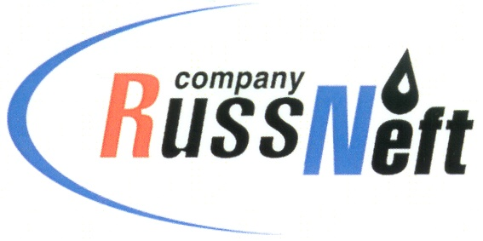
PJSC “RUSSNEFT” PRESS SERVICE

Tel.: (495) 411-63-24; (495) 411-63-21  Fax: (495) 411-63-19  E-mail: pr@russneft.ru  www.russneft.ru | 115054, Moscow,  Pyatnitskaya str., 69

PRESS - RELEASE
November 01, 2025

RussNeft Supports the "Science Volunteers" Intensive Educational Program

PJSC “RussNeft” supported the "Science Volunteers: Unmanned Aircraft Systems in the Modern World" educational program, which was held at the "Rovesnik" children's health center in Saratov.

The event was initiated by the Saratov State University of Genetics, Biotechnology, and Engineering named after N.I. Vavilov and the "Galaktika 64" Center for Gifted Children, with support from the regional Ministry of Education and numerous public organizations affiliated with the All-Russian Society of Inventors and Innovators.

The project involved students from grades 8-11, aged 14-17, from educational institutions in the Saratov Region and other regions of the country included in the "Unmanned Aircraft Systems" national project.

The program provided an excellent opportunity to immerse in the world of unmanned systems and gain new skills in engineering disciplines. Master classes, engineering competitions, project sessions, and meetings with leading experts in the unmanned aerial systems industry took place in a warm and friendly atmosphere.

Overall, the "Science Volunteers" educational intensive is a series of training sessions aimed at enhancing the creative, innovative, and rationalizing abilities of teenagers.

About the Company:

PJSC “RussNeft” ranks among the top-10 largest oil companies by crude oil production in Russia.

The Company possesses a well-balanced portfolio of assets located in the key Russian oil and gas provinces (West Siberia, Volga-Urals and Central Siberia).

The headcount of the Company is over 6,000 employees.

Press Service of PJSC "RussNeft"
Phone: (495) 411-63-24, Fax: (495) 411-63-19

