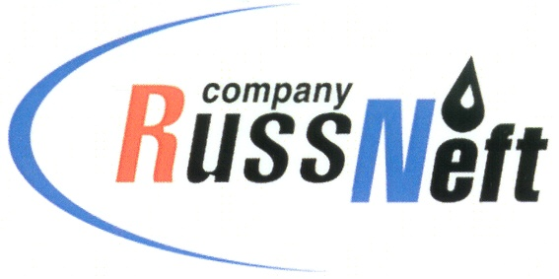
PJSC “RUSSNEFT” PRESS SERVICE

Tel.: (495) 411-63-24; (495) 411-63-21  Fax: (495) 411-63-19  E-mail: pr@russneft.ru  www.russneft.ru | 115054, Moscow,  Pyatnitskaya str., 69

PRESS RELEASE
April 21, 2026

RussNeft announces the winners of the 3rd Scientific and Technical Conference for Young Professionals

The professional panel of PJSC “RussNeft” has selected the winners of the Company`s Scientific and Technical Conference for Young Professionals.

14 specialists from the Nizhnevartovsk, Khanty-Mansiysk, Tomsk, Saratov and Ulyanovsk branches of the Company submitted their projects for the final round of the competition.

The panel named D. Shvetsov, a young employee from the Ulyanovsk branch, as the winner of the conference for his project "A set of measures aimed at reducing the cost of well construction".

Second place went to V. Sergeev, a repairman in the Saratov branch's oilfield equipment and pipeline maintenance team, for his study on the potential of using gland packing in line heater repairs.

Third place was shared between Tomsk branch employees A. Zakis, an oil, gas, and condensate production foreman, and E. Maksimov, a process engineer, for their work on modeling field pipeline protection.

The work of K. Avelichev, a chief specialist in the Ulyanovsk Branch, on the manufacture and application of a modern valve stem sealing material, was recognized as the best in the "Advantage in Implementation Possibility" category.

M. Zainulin, a chief specialist of the Khanty-Mansiysk Branch, won the "Best Rationalization Proposal" category with a project for heat recovery from Jenbacher gas piston generator sets.

A. Naimovich, a technologist of the Nizhnevartovsk Branch, was recognized in the nomination “The Best Innovation Proposal” for his presentation on a mobile solution for early water discharge at a well pad.

When evaluating reports and presentations, the economic viability, topicality, and originality of the topic being developed were taken into consideration.

The main objectives of the conference are to stimulate creative and research activities of the Company's talent pool.

About the Company:
PJSC “RussNeft” ranks among the top-10 largest oil companies by crude oil production in Russia.
The Company possesses a well-balanced portfolio of assets located in the key Russian oil and gas provinces (West Siberia, Volga-Urals and Central Siberia).
The headcount of the Company is around 6,000 employees.

Press Service of PJSC "RussNeft"
Phone: (495) 411-63-24, Fax: (495) 411-63-19
E-mail: pr@russneft.ru

