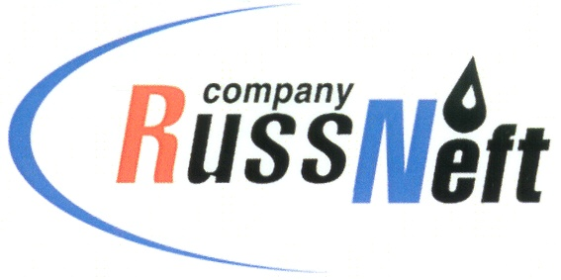
PJSC “RUSSNEFT” PRESS SERVICE

Tel.: (495) 411-63-24; (495) 411-63-21  Fax: (495) 411-63-19  E-mail: pr@russneft.ru  www.russneft.ru | 115054, Moscow,  Pyatnitskaya str., 69

PRESS - RELEASE
August 29, 2025

RussNeft signed a social partnership agreement with the administration of the Nizhnevartovsk district of the Khanty-Mansi Autonomous Okrug

PJSC “RussNeft” and the administration of the Nizhnevartovsk district of the Khanty-Mansi Autonomous Okrug - Yugra annually conclude an agreement to implement socially significant social projects.

In 2025, the Company allocated 6.3 million rubles for charitable projects under an agreement with the administration. The funds were used to repair the Znamenskaya Church in the village of Laryak, improve the territory of the Temple in honor of the holy martyr Hermogenes and all the New Martyrs and Confessors of the Russian Church in the village of Novoagansk, and improve the territory of the Temple of Blessed Xenia of Petersburg in the village of Zaitseva Rechka.

RussNeft continues active joint work with the government of Yugra in the territories of the company's production presence.

About the Company:
PJSC “RussNeft” ranks among the top-10 largest oil companies by crude oil production in Russia.
The Company possesses a well-balanced portfolio of assets located in the key Russian oil and gas provinces (West Siberia, Volga-Urals and Central Siberia).
The headcount of the Company is around 6,000 employees.

Press Service of PJSC "RussNeft"
Phone: (495) 411-63-24, Fax: (495) 411-63-19
E-mail: pr@russneft.ru

