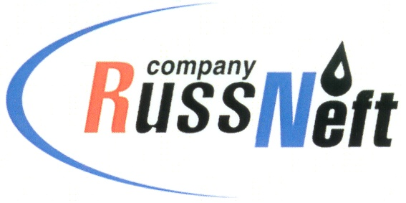

PJSC “RUSSNEFT” PRESS SERVICE

Tel.: (495) 411-63-24; (495) 411-63-21  Fax: (495) 411-63-19  E-mail: pr@russneft.ru  www.russneft.ru | 115054, Moscow,  Pyatnitskaya str., 69

PRESS RELEASE
July 1, 2024

RussNeft supported creative session in Rovesnik

PJSC "RussNeft" supported Volga Rainbow project, participated by 177 gifted children - winners of creative competitions in Saratov. Volga Rainbow is an art school based at Rovesnik recreation center, hosted master classes and creative meetings of schoolchildren with students of theater universities, actors and teachers of Filatov Moscow Theater College, Schnittke Saratov Regional Philharmonic, Choral Music Theater, Fedin State Museum, Pushkin Regional Library for Children and Youth, Parafraz ensemble of folk instruments, Circus Art-Alle center of circus art.

This year the creative session was dedicated to the poetic heritage of A.S. Pushkin and was held under the motto: PUSHKIN. To be modern!

At the closing ceremony of the session, Natalia Shchelkanova, Minister of Culture of the Saratov Region, wished the children further success, inspiration, and dedication to art. She expressed gratitude to the management of RussNeft and the Safmar charitable foundation for their constant contribution to the development of the Rovesnik camp and for supporting talented children and youth of the region.

About the Company:
PJSC "RussNeft" ranks among the top-10 largest oil companies by crude oil production in Russia.
The Company possesses a well-balanced portfolio of assets located in the key Russian oil and gas provinces (West Siberia, Volga-Urals and Central Siberia) as well as in Azerbaijan.
The headcount of the Company is around 7,000 employees.

PJSC “RussNeft” Press Service
Tel.: (495) 411-63-24, Fax: (495) 411-63-19
E-mail: pr@russneft.ru

