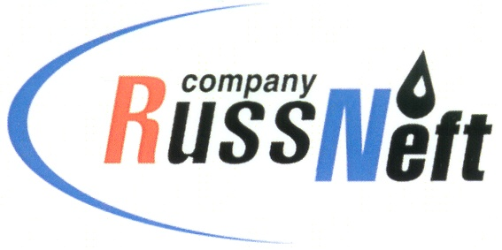
PJSC “RUSSNEFT”
PRESS SERVICE

Tel.: (495) 411-63-24; (495) 411-63-21  Fax: (495) 411-63-19  E-mail: pr@russneft.ru  www.russneft.ru | 115054, Moscow,  Pyatnitskaya str., 69

PRESS - RELEASE
May 23, 2024
"RussNeft" supports opera festival in Saratov

PJSC ”RussNeft” supported the Sobinov Music Festival in Saratov. The festival is held for the 37th year on a row and is dedicated to the 220th anniversary of the birth of Mikhail Glinka and the 90th anniversary of the birth of Alfred Schnittke.
The Sobinov Festival is an example of cultural and educational activity to attract the wide audience to musical and theatrical art.
The Opera Festival was created in 1986 and is held annually. The Saratov branch of RussNeft strives to support meaningful cultural projects of the international level. Among them are Saratov Sufferings International Film Festival of Documentary Drama, the L.A. Ruslanova All–Russian Folk Song Competition, the Tabakov Lessons cultural and educational project festival, and the Svyatoslav Knushevitsky International Cello Competition.
This year, the Saratov branch of RussNeft did not stand by idly and allocated charitable funds for the XXXVII Sobinov Music Festival.

About the Company:
PJSC “RussNeft” ranks among the top-10 largest oil companies by crude oil production in Russia.
The Company possesses a well-balanced portfolio of assets located in the key Russian oil and gas provinces (West Siberia, Volga-Urals and Central Siberia) as well as in Azerbaijan.
The headcount of the Company is around 7,000 employees.

Press Service of PJSC "RussNeft"
Phone: (495) 411-63-24
Fax: (495) 411-63-19
E-mail: pr@russneft.ru

