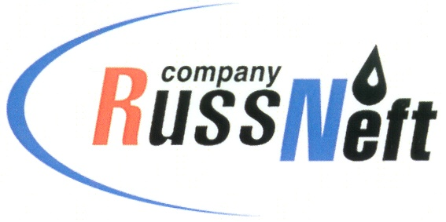

PJSC “RUSSNEFT” PRESS SERVICE

Tel.: (495) 411-63-24; (495) 411-63-21  Fax: (495) 411-63-19  E-mail: pr@russneft.ru  www.russneft.ru | 115054, Moscow,  Pyatnitskaya str., 69

PRESS RELEASE
October 10, 2024

RussNeft continues the Silver Age project in Rovesnik

PJSC “RussNeft” has supported the Silver Age project. The project for the elderly is being implemented on the basis of the Rovesnik wellness center in collaboration with the Ministry of Labor and Social Protection of the Saratov region.
In autumn, the wellness center hosted 100 representatives of the older generation from various parts of the Saratov region. Among the guests, the veteran organization of Saratovneftegaz was given a preeminent place. The company made a significant contribution to the formation and development of the Volga region oil and gas industry, and was also directly involved in the construction of the Rovesnik wellness camp.
Within the framework of the project, an event dedicated to the 10th anniversary of the Silver Age was held, attended by Denis Davydov, Minister of Labor and Social Protection of the Saratov region. Addressing the participants with a welcome speech, he thanked the company for its support of the project.

About the Company:

PJSC "RussNeft" ranks among the top-10 largest oil companies by crude oil production in Russia.
The Company possesses a well-balanced portfolio of assets located in the key Russian oil and gas provinces (West Siberia, Volga-Urals and Central Siberia).
The headcount of the Company is around 7,000 employees.

PJSC “RussNeft” Press Service
Tel.: (495) 411-63-24, Fax: (495) 411-63-19
E-mail: pr@russneft.ru

